Properties files and native dll's

# Native dll libraries

1. In order for an application that uses scapi jar file to work with the dll there must be a path in the environment to the location of the dll. This path can be created using some kind of an installation tool.
2. In our project the path will be under lib. The native path will be defined from the JavaSrc source folder in the build configuration as follows.

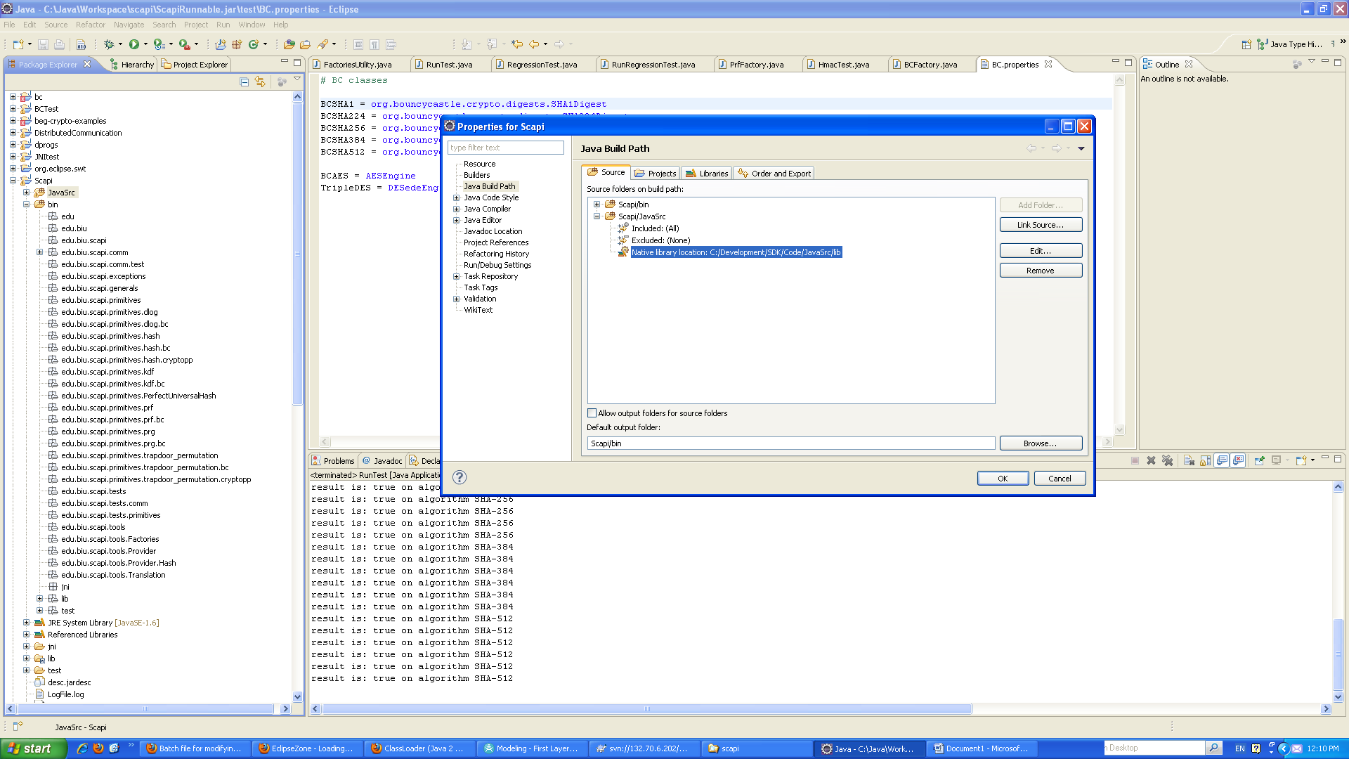

# Properties files loaded from a jar

1. Do not use the following code:

//load the defaultProviderFileName file

defaultProviderMap.load(**new** FileInputStream(defaultProviderFileName));

The above code does not work from a jar file.

1. For a properties file (and any other files) to be loaded inside a jar file the following code must be used.

InputStream in=(InputStream) getClass().getResourceAsStream(algsInTypeFileName);

algsInType.load(in);

This code works also if the code is generated as a jar where algsInTypeFileName should include the path to the properties file under the bin directory.

1. In order for the properties files to be exported inside the jar file the bin directory should be defined as a source folder as follows:

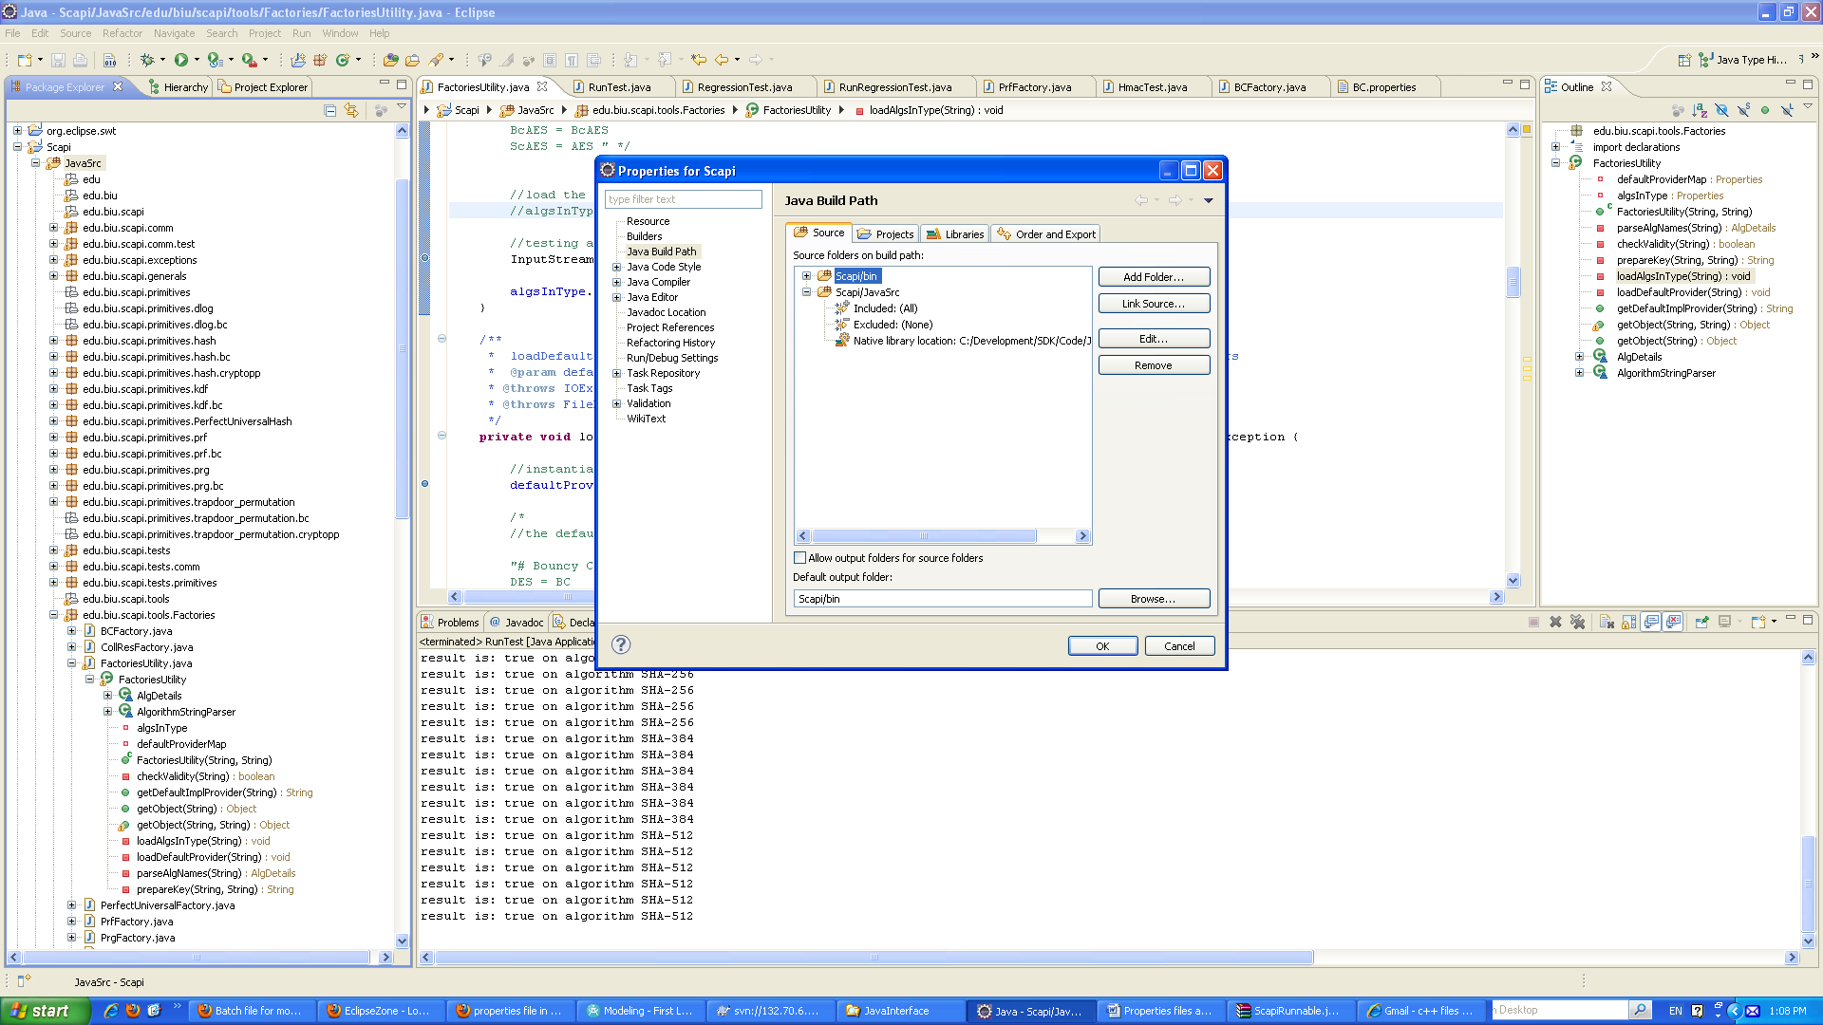

1. When bin is defined as a source folder the generated jar includes the properties under bin or subfolders of bin.

The jar file has these files under the subfolder as can be seen in the following TestLib project that includes this jar. The properties files are under \bin\test and thus in the jar file appear under test.

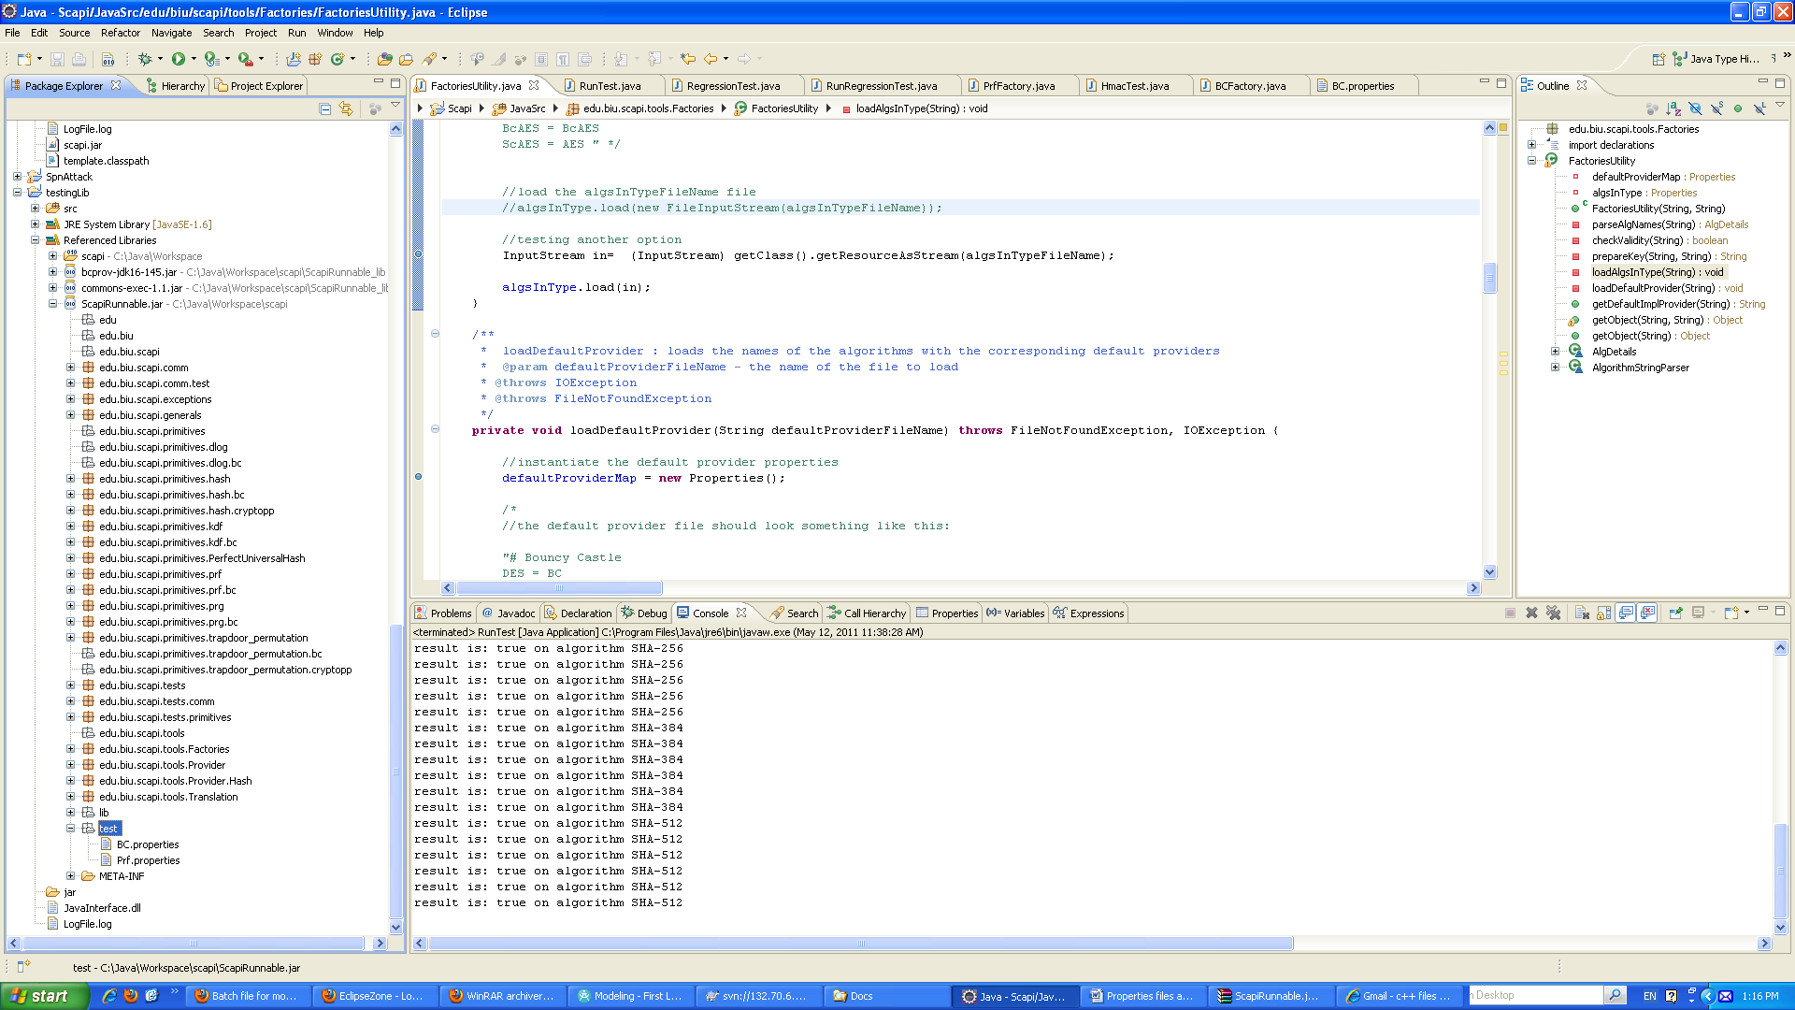

1. The properties files cannot be edited from the project that includes this jar. In order to edit the properties files without generating a new jar file, the jar file should be opened using an archiver tool (such as winrar) and be edited manually from there.